HOMEWORK: Ansible

1. Screenshoots of the key pair generate (pun key) on the controller

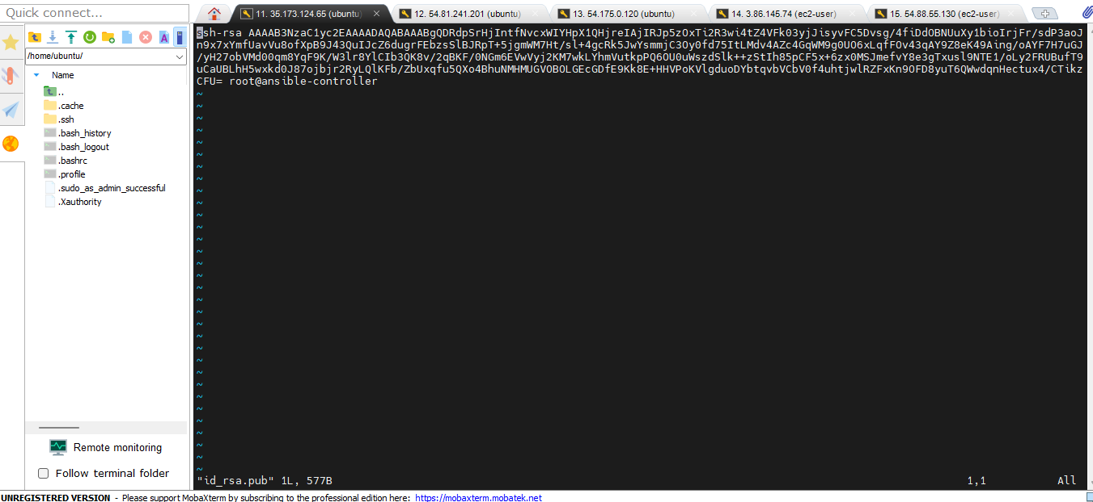

1. Screenshot of the worker’s file .ssh/authorized key showing the controller keypair

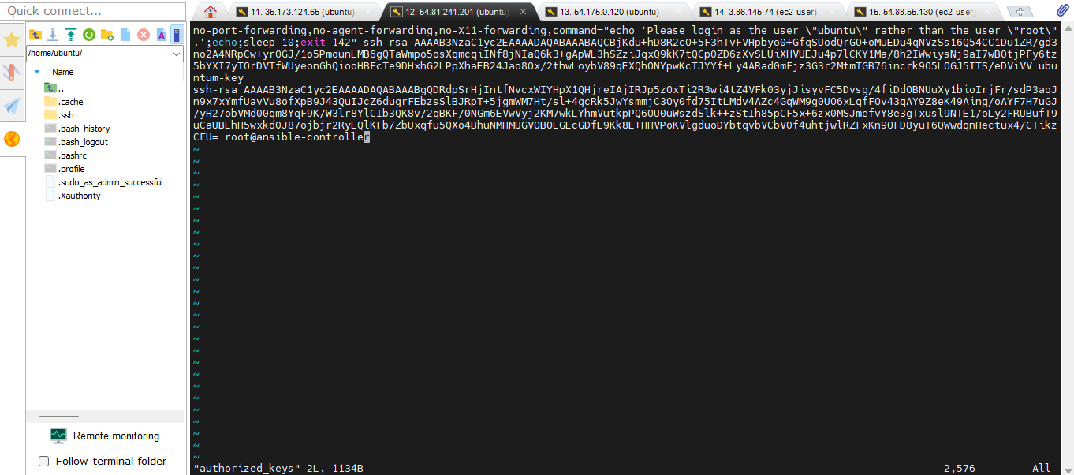

1. Ansible installed on the controller

1. The inventory file on the controller

1. The ping showing all the clients successfully ping by controller

1. Controller running the playbook

1. Output of play1 on all the ubuntu-clients